Comparison between Resource Based
View and Porter's Five Forces

Claire Yuanqiu Nie
National University of Singapore

Introduction
This report aims to examine Porter’s Five-force framework and Resource Based View theory by discussing each theory’s background, unit of analysis, assumptions, social welfare implications, and lastly compare and contrast the two theories.

Resource Based View (RBV)
The RBV model emphasizes firm’s internal resources as fundamental determinants of its sustained competitive advantage. RBV takes individual resources as a unit of analysis. According to RBV, firms have two types of resources: tangible and intangible (Diagram 1). Tangible resources refer to physical assets owned by firm, such as land, plants and machines. However, intangible assets lack a physical form such as reputation, intellectual property rights and culture. Intangible assets require a long time to be built and cannot be easily bought.

There are two critical assumptions for RBV theory. The first assumption is that companies control unique set of skills, capabilities and resources. The second assumption is that such heterogeneity will persist because resources are not perfectly mobile across firms (Diagram 1).

To determine if a company's resources contribute to its competitive advantage, VBR looks at if the resources satisfy the VRIO (Valuable, Rare, hard to Imitate and Organization) framework (Diagram 2). Firstly, there must be demand and appropriability in order for the resources to be valuable. The value is subject to the environment and technological change. As for rarity, resources that are scarce leads to competitive advantage whereas resources that can be easily acquired by other firms results in competitive parity. Resources that are valuable and rare, but imitable, leads to temporary competitive advantage. To achieve long-term competitive advantage, resources must be difficult to imitate by rivals. Lastly, the company must be organized in a way that can maximum the usage of the resources. In summary, only resources that meet the above-mentioned four criteria can help companies achieve sustained competitive advantage (Barney, J.).

Porter’s five-force framework
Porter's five-force framework uses an industry or a specific segment within the industry as its unit of analysis. This framework focuses on five parties: Entry barriers, Rivalry, Substitutes, Suppliers and Buyers. The assumption is that each party compete with each other and maximize its own profitability.

Porter’s five forces are as follows: Entry Barriers are the cost of entering the industry. High entry barriers make it harder for entrants to enter the industry and vice versa. Rivalry poses competition to firms by various strategies such as price cutting and innovation. Substitutes provide alternatives for buyers to switch from one product to the other. This in turn determines the bargaining power of buyers and firms. The bargaining power of Suppliers affect the profit potential of firms. Lastly, the bargaining power of Buyers determine the ability for firms to charge higher price and reap more profits. Porter argues that companies need to analyze competitions that company face within the industry in order to gain sustainable competitive advantage and respond favorably to the five forces. (Barney,W., 2012)

Compare and Contrast
Both theories serve to as tools to help firm identify profitability potential and achieve higher performance level. However, they are three differences between two theories. Firstly, Porter’s five-force framework adopts a macroeconomic view of the industry whilst the RBV approach focuses on the micro perspective of the firm. Secondly, Porter’s theory builds on structure-conduct-performance paradigm, emphasizing the accumulation of resources is part of the implementation of the strategy influenced by conditions and constraints in the external environment; this is different from RBV where managers apply their resources and capabilities to create sustained comparative advantage. Therefore, Porter’s theory ignores the potential use of internal resources to create strategies. Thirdly, RBV represents efficiency of how resources maximises capacity and satisfy customer demand. Porter’s approach focuses on firm’s ability to reap the benefits of the market that differentiates between industries.

Social Welfare Implication
Social welfare refers to efficiency allocation of resources in the market and is only maximized in a perfectly competitive market. Porter’s theory is not consistent with maximizing social welfare because firm's profitability depends on its strategy to create imperfectly competitive market by leveraging on the five forces such as creating substantial entry barrier (Barney, 1986). This confers firms the bargaining power to increase price, control supply and reduce R&D investment. As a result, society may suffer from less innovation and higher prices which indicate a welfare loss. However, RBV argues that firms achieve economic efficiency simply by fully exploiting its internal available resources which are unique and immobile (Demsetz, 1973) instead of competing with or even exploiting other parties. Hence, profit for firms from the efficient usage of resources does not lead to welfare loss.

Conclusion
Both Porter’s Five Forces and RBV focus on achieving profit maximisation through attaining sustained competitive advantage. The difference lies in that Porter focuses on external environment while RBV focuses on the internal resources the firm. A holistic approach is to examine both external and internal factors to achieve and sustain competitive advantage.

APPENDIX
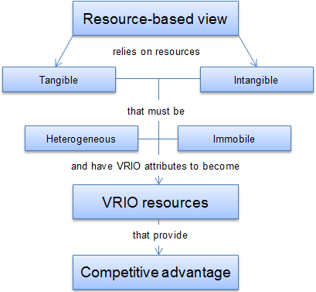

Diagram 1

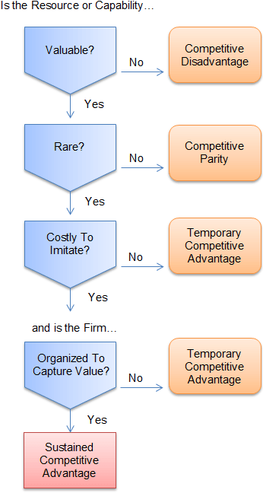
Diagram 2
References
Barney, J. (1991). Firm Resources and Sustained Competitive Advantage. Journal Management, 17(1), 99-120.
Barney J.; Hesterly, S. (2012). Strategic Management and Competitive Advantage. New Delhi, 40-48.
Porters Five Forces Model of Competitive Advantage. (2011, January 1). Retrieved from http://www.ukessays.com/essays/business/porters-five-forces-model-of-competitive-advantage-business-essay.php#ixzz3RpMIjENK.
Porter, M. (1981). The contributions of industrial organization to strategic management. Academy of Management Review, 6: 609-620.
Rothaermel, F. T. (2012). Strategic Management: Concepts and Cases. McGraw-Hill/Irwin, p. 5

